

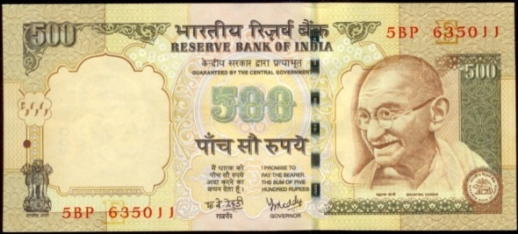


Volume: 3/09
FISCAL WEEKLY

QUOTE OF THE WEEK
Invest in yourself. Your career is the engine of your wealth.
-Paul Clitheroe





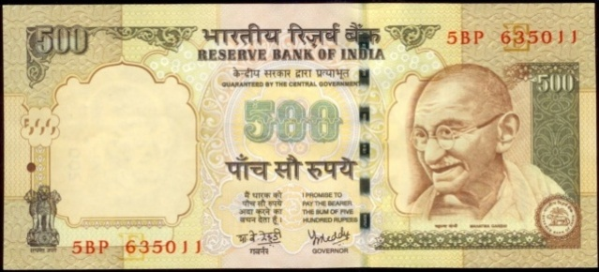
-A dash of insight
NEW CHANGES
FIIs/RFPIs can now invest up to 100 per cent under PIS in M/s Crompton Greaves Consumer Electricals Limited
The Reserve Bank of India has today notified that Foreign Institutional Investors (FIIs)/Registered Foreign Portfolios Investors (RFPIs) can now invest up to 100 per cent of the paid up capital of M/s Crompton Greaves Consumer Electricals Limited under the Portfolio Investment Scheme (PIS).

The Reserve Bank has stated that the company has passed resolutions at its Board of Directors’ level and a special resolution by the shareholders, agreeing for enhancing the limit for the purchase of its equity shares and convertible debentures by FIIs/RFPIs. The purchases could be made through primary market and stock exchanges

DO YOU KNOW?
What is the ‘Hamptons Effect’?
The Hamptons Effect refers to a dip in trading prior to the Labor Day weekend followed by increased trading volume as traders and investors return from the long weekend. The term implies that many of the large scale traders on Wall Street spend the last days of summer in Hamptons, a traditional summer destination for the wealthy of New York City. The increased volume of the Hamptons Effect can be positive in the form of a rally as portfolio managers place trades to firm up overall returns going into the end of the year or it can be on the negative side if those same portfolio managers decide to take profits rather than opening or adding to positions.
Read more: Hamptons Effect Definition | Investopedia http://www.investopedia.com/terms/h/hamptons-effect.asp#ixzz4JwiwY07Y
Follow us: Investopedia on Facebook



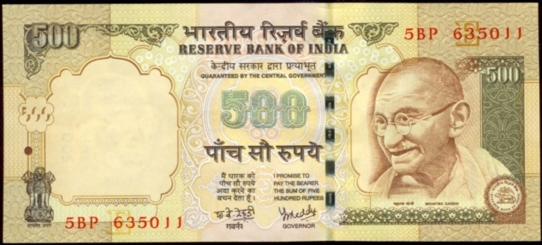
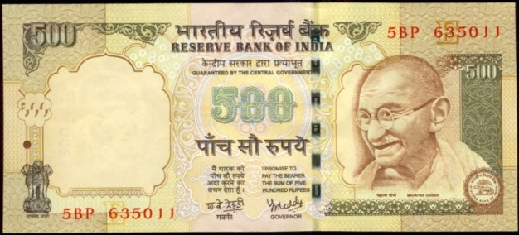

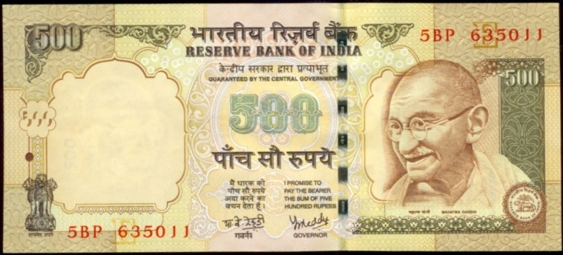

BSE’s INR 1300 Crore IPO
- BSE will be listing its shares on the National Stock Exchange (NSE)
- The shares will be put on sale via Offer For Sale, which lets existing promoters dilute or divest their entire stake
- The Singapore Exchange which is one of the stake holders in the exchange, it likely to sell off its entire 4.7% holding
- BSE will be selling 29.96 million shares or nearly 28% of its stake in the IPO
- Lead merchant banker-Edelweiss Financial Services

Winner of the week:
Y Sai Sailesh

Question of the Week
Which private sector bank has become the first in India to open
dedicated branch for startups?
Send your answer at infofinancendim@gmail.com along with your passport size photograph.


Editorial by: Aditi Haldia, Juhi Aswani, Mansi Handa, Himanshu , Vikramjeet Verma
WORD OF THE WEEK
Participatory notes
P-notes are offshore derivative instruments with Indian shares as underlying assets. Brokers and FIIs registered with SEBI issue the instruments and make investments on the FII’s behalf. Brokers must report their P-note issuance status to SEBI each quarter. Investing through P-Notes is very simple and hence very popular amongst foreign institutional investors.





